1. Climate-Smart Agriculture.
The five major practical activities implemented to achieve Climate-Smart Agriculture are:

1. Environmental protection; Agroforestry and Tree Planting
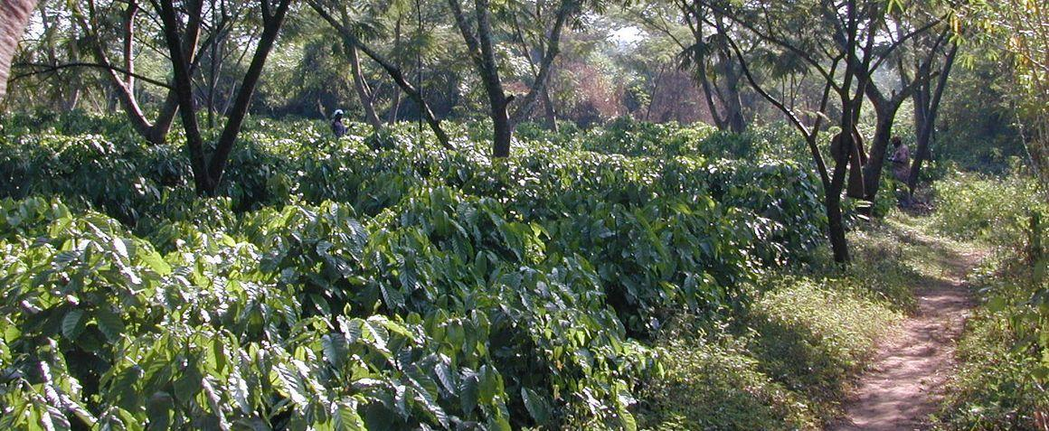
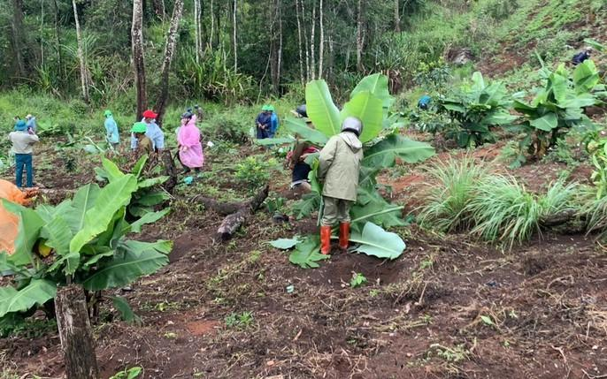
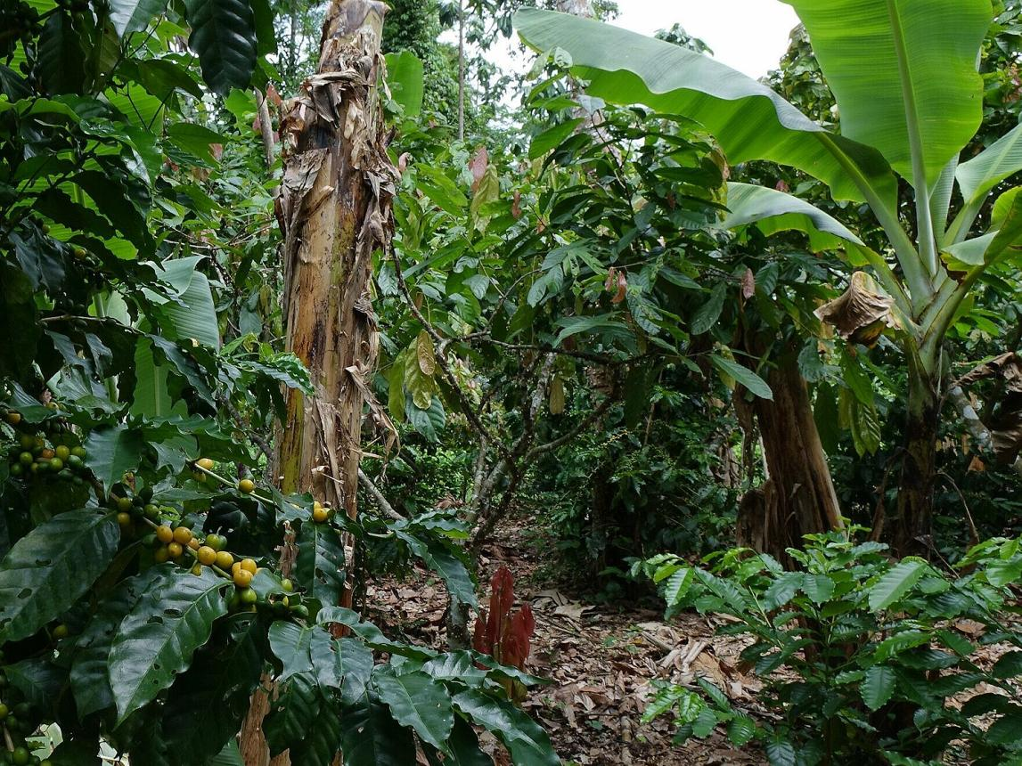
This is the most widely promoted CSA intervention in the Rwenzori region.
Key activities include:
- Planting shade trees in plantations.
- Establishing woodlots for fuel and timber.
- Planting fruit trees for nutrition and income.
- Restoring degraded hillsides and riverbanks.
- Conserving indigenous tree species.
Benefits
- Reduces heat stress on coffee.
- Improves soil fertility through leaf litter.
- Stores carbon.
- Protects biodiversity.
- Diversifies household income.

2. Soil and Water Conservation
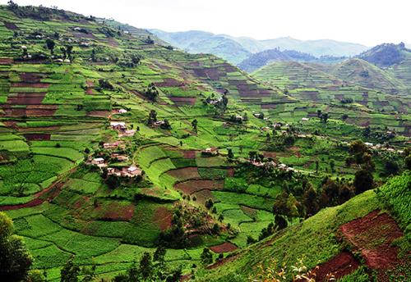
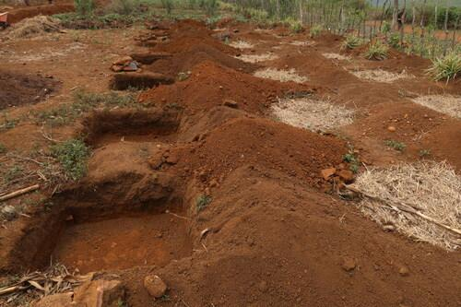
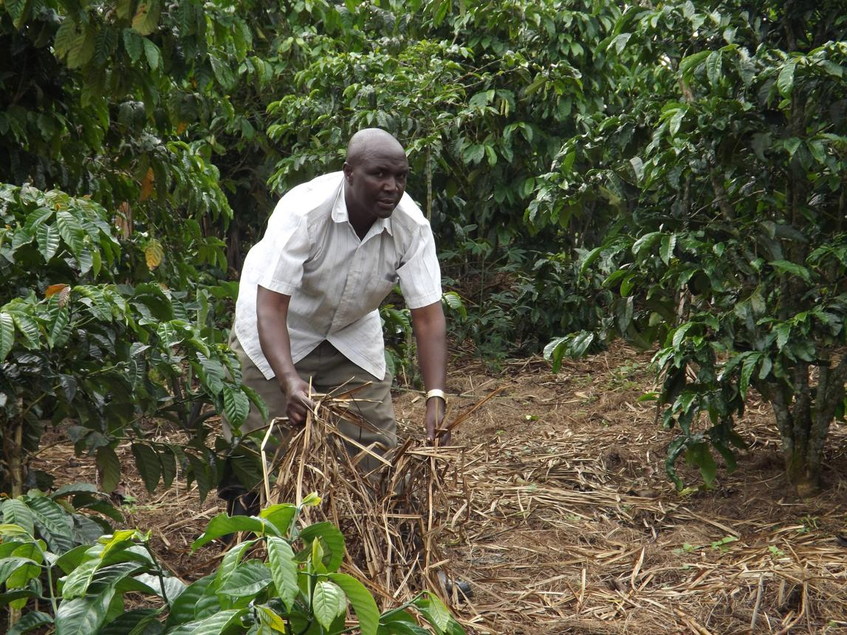
Because the Rwenzori landscape is mountainous, preventing soil erosion is essential.
Major practices
- Terracing.
- Contour farming.
- Grass strips.
- Stone bunds.
- Mulching.
- Composting.
- Rainwater harvesting.
- Drainage channels.
Benefits
- Prevents soil erosion.
- Conserves moisture.
- Reduces floods and landslides.
- Improves soil organic matter.
- Maintains long-term productivity.

3. Climate-Resilient Crop and Livestock Production
Farmers are encouraged to adopt improved technologies that can withstand changing weather.
Activities
- Planting drought- and disease-tolerant crop varieties.
- Introducing improved coffee and banana varieties.
- Diversifying enterprises (coffee, cocoa, bananas, beans, vegetables, fruits).
- Improving pasture management.
- Zero grazing and improved livestock housing.
- Improved fodder production.
Benefits
- Stable yields despite climate variability.
- Reduced crop failure.
- Better livestock productivity.
- Improved household food security.

4. Integrated Soil Fertility and Pest Management
Healthy soils and reduced pest pressure increase resilience to climate change.
Activities
- Compost and farmyard manure application.
- Green manuring.
- Crop rotation.
- Intercropping.
- Integrated Pest Management (IPM).
- Biological pest control.
- Reduced dependence on synthetic pesticides.
Benefits
- Improved soil fertility.
- Reduced production costs.
- Healthier ecosystems.
- Better resistance to pests and diseases.
- Increased yields.

5. Farmer Capacity Building and Climate Information Services
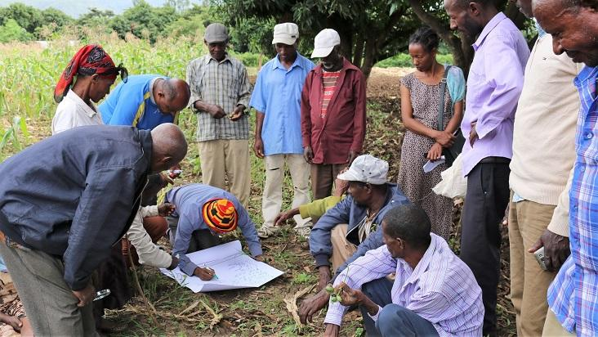
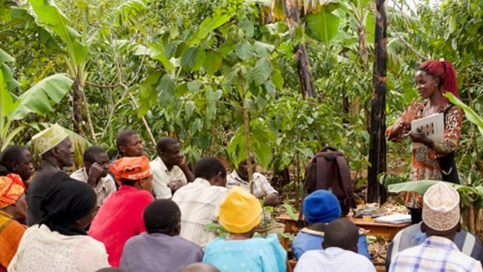
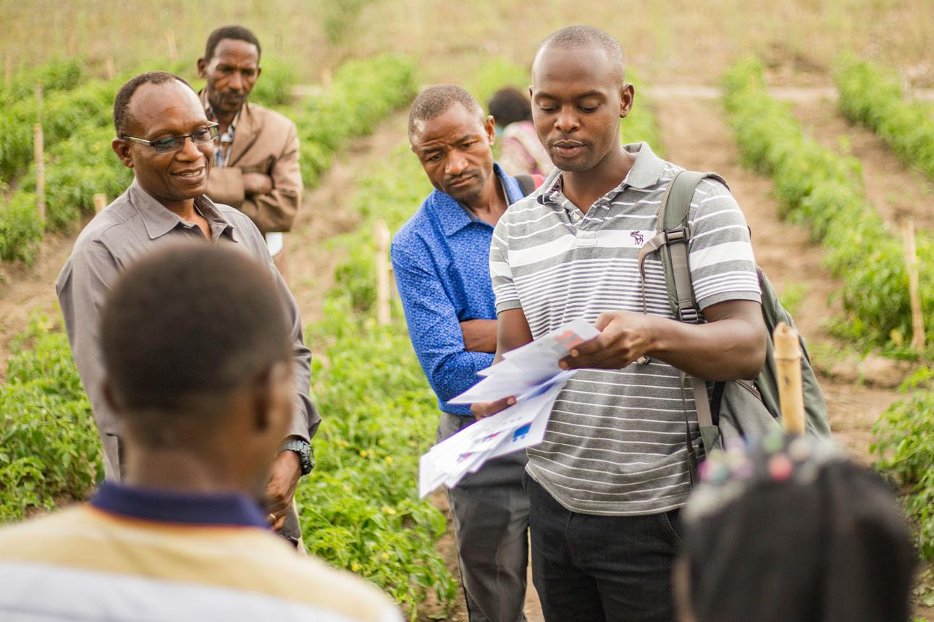
Knowledge transfer is critical for successful CSA adoption.
Activities
- Farmer Field Schools.
- Demonstration gardens.
- Climate and weather advisory services.
- Community-based extension.
- Formation of farmer groups and cooperatives.
- Record keeping and farm business management.
Benefits
- Faster adoption of CSA technologies.
- Better farm decision-making.
- Improved access to markets.
- Increased resilience to climate shocks.
- Stronger farmer organizations.

Farm-to-Market Enterprise Development Program (F2MP)

Tagline: Empowering Farmers, Adding Value, Connecting Markets.
This name reflects the complete agricultural business pathway—from organizing farmers into strong institutions, enhancing value addition and entrepreneurship, to linking them with profitable domestic and international markets.

Goal
To strengthen farmer organizations and agribusiness enterprises through value addition, entrepreneurship development, market integration, and sustainable trade partnerships that increase household incomes and employment opportunities.

Key Activities

1. Farmer Organization, Strengthening and Enterprise Competitiveness
- Mobilize and register farmer groups, cooperatives, and producer organizations.
- Strengthen governance, leadership, and financial management.
- Promote inclusive participation of women, youth, and persons with disabilities.
- Develop organizational strategic and business plans.
- Build cooperative management and record-keeping systems.
- Promote innovation in agricultural technologies.
- Support certification (Organic, Fairtrade, Rainforest Alliance, etc.) where appropriate.
- Improve product traceability systems.
- Promote climate-smart agribusiness models.
- Encourage digital record keeping and business management tools.

2. Agribusiness Development
- Train farmers in agribusiness management and entrepreneurship.
- Promote business planning and enterprise development.
- Support producer-led agribusiness enterprises.
- Facilitate access to business development services.
- Improve financial literacy and investment readiness.

3. Value Addition and Agro-processing & Market access.
- Promote post-harvest handling and quality management.
- Establish and strengthen processing facilities.
- Support packaging, branding, and product certification.
- Develop new value-added agricultural products.
- Improve compliance with national and export quality standards.
- Link farmers with local, regional, and international buyers.
- Facilitate contract farming and structured marketing arrangements.
- Organize trade fairs, business forums, and buyer–seller meetings.
- Promote digital marketing and e-commerce platforms.
- Support market intelligence and price information systems.

4. Financial Inclusion and Enterprise Financing
- Strengthen Village Savings and Loan Associations (VSLAs).
- Facilitate access to affordable agricultural finance.
- Link farmer organizations to banks and microfinance institutions.
- Promote warehouse receipt and inventory financing systems.
- Build farmers' capacity in savings, investment, and financial management.

5. Employment and Youth Enterprise Development
- Support youth-led agribusiness startups.
- Develop skills in agro-processing and agribusiness.
- Promote rural employment opportunities.
- Strengthen women-owned agricultural enterprises.
- Facilitate mentorship and incubation for agribusiness entrepreneurs.

4. Community well Fair- Nutrition & Household Food Security, Gender Inclusivity, Health & Well-being and Education

Key Activities

1. Nutrition and Household Food Security
- Promote diversified household food production through kitchen and backyard gardens.
- Establish school and community demonstration gardens.
- Train households in balanced diets, food preparation, preservation, and storage.
- Promote nutrition-sensitive agriculture and biofortified crops.
- Support household food security planning and resilience during lean seasons.
- Conduct nutrition awareness campaigns for women, youth, and caregivers.

2. Health and Well-being
- Conduct community health education and behavior change campaigns.
- Promote maternal, newborn, and child health services.
- Support water, sanitation, and hygiene (WASH) initiatives.
- Facilitate community health outreach and disease prevention campaigns.
- Promote mental health awareness and psychosocial well-being.
- Encourage healthy lifestyles through physical activity and substance abuse prevention.

3. Education and Skills Development
- Support school enrollment, attendance, and retention, especially for vulnerable children.
- Promote adult literacy and functional education.
- Provide vocational and life-skills training for youth and women.
- Establish community learning and resource centers.
- Promote digital literacy and access to learning technologies.
- Support school nutrition and health programs.

4. Social Inclusion and Protection
- Strengthen community support groups and self-help initiatives.
- Promote gender equality and women's leadership.
- Empower youth through leadership and entrepreneurship opportunities.
- Support persons with disabilities and other vulnerable groups.
- Facilitate access to social protection and referral services.

5. Community Awareness and Behaviour Change
- Conduct awareness campaigns on nutrition, health, education, and environmental stewardship.
- Promote positive parenting and child protection.
- Facilitate community dialogues on social development issues.
- Strengthen local leadership in community development planning.

